

PIC 8259A Project

Computer Architecture

From Intel’s Data Sheet

|  |  |
| --- | --- |
| Name | ID |
| Abdallah Mohamed | 2001803 |
| Ahmad Youssef | 2002238 |
| Mohamed Mostafa | 2001299 |

# Table of Contents

# Overview

# Control Logic Block

## Block Diagram

## Block Ports

|  |  |  |  |  |
| --- | --- | --- | --- | --- |
| Pin Name | Pin Type | In | Bits | What it indicates |
| A0 | Input |  | 1 | Used to decipher various commands (ICWs and OCWs) |
| wren | Input |  | 1 | When high then CPU writes commands (ICWs or OCWs) to the PIC on the Data Bus (D7-D0) |
| rden | Input |  | 1 | when high then CPU reads status (IRR, ISR or IMR) from the PIC On the Data Bus (D7-D0) |
| DBus | Input |  | 8 | The ICWs, OCWs, PIC Status or Vector Address get transferred via the data bus |
| ICW1flag | Input |  | 1 | When high then the CPU writes ICW1 to the PIC on the Data Bus (D7-D0) |
| ICW2flag | Input |  | 1 | When high then the CPU writes ICW2 to the PIC on the Data Bus (D7-D0) |
| ICW3flag | Input |  | 1 | When high then the CPU writes ICW3 to the PIC on the Data Bus (D7-D0) |
| ICW4flag | Input |  | 1 | When high then the CPU writes ICW4 to the PIC on the Data Bus (D7-D0) |
| OCW1flag | Input |  | 1 | When high then the CPU writes OCW1 to the PIC on the Data Bus (D7-D0) |
| OCW2flag | Input |  | 1 | When high then the CPU writes OCW2 to the PIC on the Data Bus (D7-D0) |
| interruptLocation | Input |  | 3 | The location of the highest priority interrupt to the IRR |
| LTIM | Output | ICW1 | 1 | Determines if the PIC works in the level (when high) or edge interrupt mode |
| ADI | Output | ICW1 | 1 | The Address Interval |
| SNGL | Output | ICW1 | 1 | When high then there’s no cascading nor ICW3 command issued |
| IC4 | Output | ICW1 | 1 | When high then ICW4 command must be read from the CPU |
| TReg |  | ICW2 | 5 | Adding these 5 bits to the 3 bits of the interrupt location to get the vector address |
| SReg | Output | ICW3 | 8 | Determines which IR input has a slave (when high) and which has not |
| SFNM | Output | ICW4 | 1 | When high then the PIC works in the special fully nested mode |
| BUF | Output | ICW4 | 1 | Determines if the PIC in buffered mode or not with the help of MS flag |
| MS | Output | ICW4 | 1 | Determines if the PIC in buffered mode or not with the help of BUF flag |
| AEOI | Output | ICW4 | 1 | When high then the End of Interrupt (EOI) will be Automatic |
| MReg | Output | OCW1 | 8 | Interrupt Mask |
| R | Output | OCW2 | 1 | End of Interrupt, Automatic Rotation, Specific Rotation |
| SL | Output | OCW2 | 1 | End of Interrupt, Automatic Rotation, Specific Rotation |
| EOI | Output | OCW2 | 1 | End of Interrupt, Automatic Rotation, Specific Rotation |
| LReg | Output | OCW2 | 3 | IR Level to be acted upon |
| readIRR | Output |  | 1 | When high then the IRR is transferred to the CPU in the read status process |
| readISR | Output |  | 1 | When high then the ISR is transferred to the CPU in the read status process |
| readIMR | Output |  | 1 | When high then the IMR is transferred to the CPU in the read status process |
| vectorAddress | Output |  | 8 | Address of the subroutine to be executed to handle the interrupt |

## Test Bench

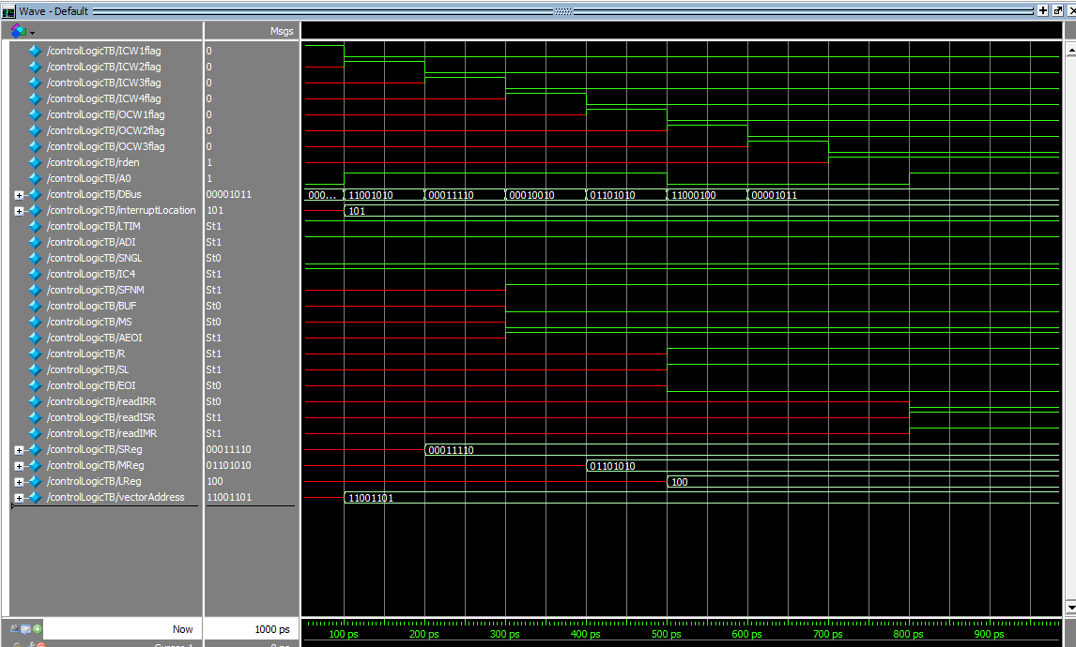

Figure : All ICWs and OCWs received.

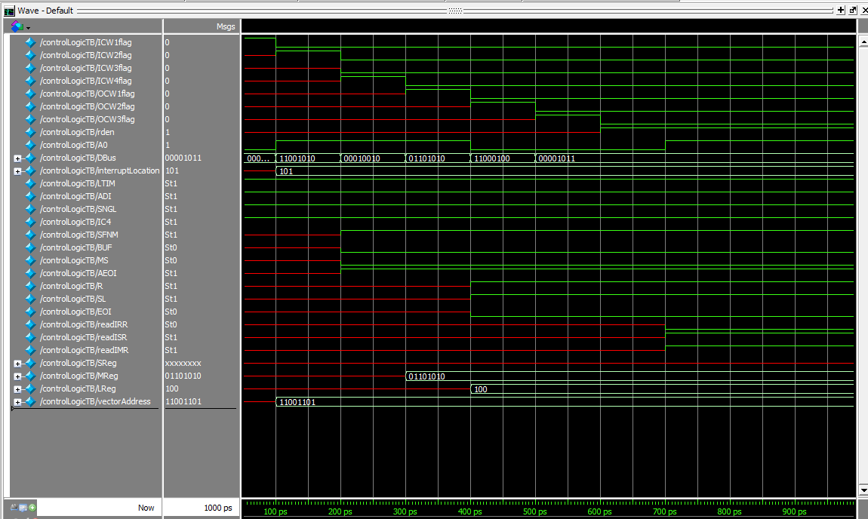

Figure : All ICWs (except ICW3) and All OCWs

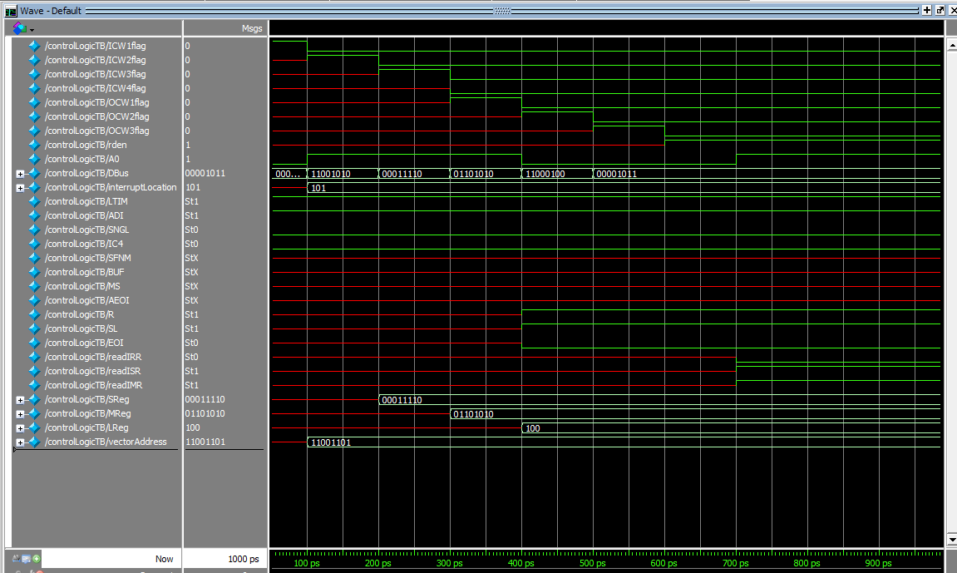

Figure : All ICWs (except ICW4) and all OCWs

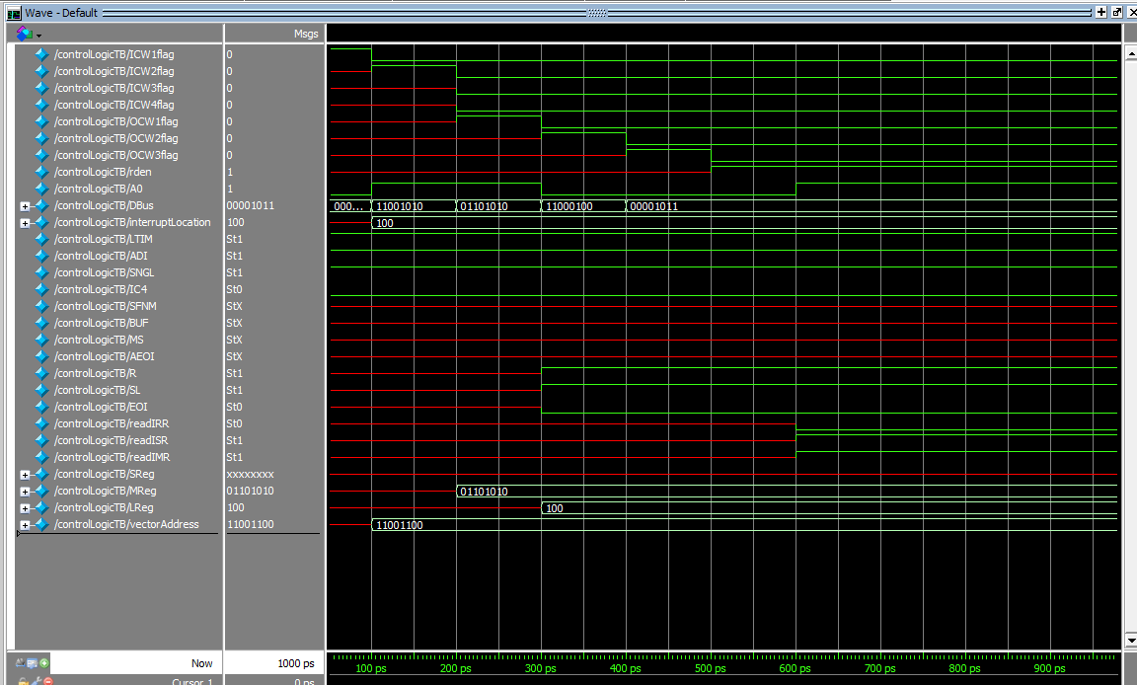

Figure : All ICWs (except ICW3&4) and all OCWs

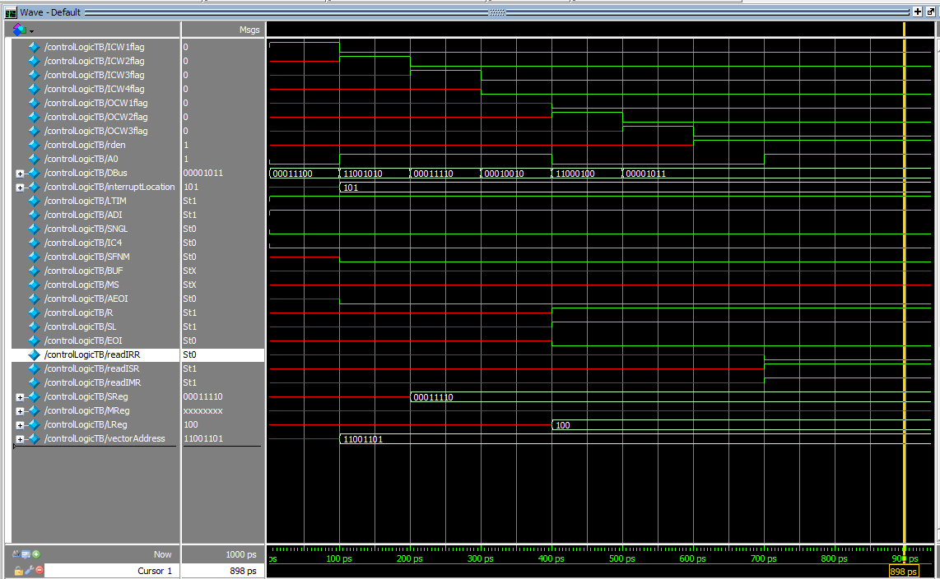

Figure : All ICWs (except ICW4) and all OCWs, but this case with default SFNM and AEOI values

# Read Write Logic

## Block Diagram

## Block Ports

|  |  |  |  |
| --- | --- | --- | --- |
| Pin Name | Pin Type | Bits | What it indicates |
| A0 | Input | 1 | Used to decipher various commands (ICWs and OCWs) |
| CS | Input | 1 | When active the CPU could read or write using the WR or RD |
| WR | Input | 1 | When active (also CS should be active) then CPU writes commands (ICWs or OCWs) to the PIC on the Data Bus (D7-D0) |
| RD | Input | 1 | When active (also CS should be active) then CPU reads status (IRR, ISR or IMR) from the PIC On the Data Bus (D7-D0) |
| dataBus | Input | 8 | The ICWs, OCWs, PIC Status or Vector Address get transferred via the data bus |
| ICW1 | Output | 1 | When high then the CPU writes ICW1 to the PIC on the Data Bus (D7-D0) |
| ICW2 | Output | 1 | When high then the CPU writes ICW2 to the PIC on the Data Bus (D7-D0) |
| ICW3 | Output | 1 | When high then the CPU writes ICW3 to the PIC on the Data Bus (D7-D0) |
| ICW4 | Output | 1 | When high then the CPU writes ICW4 to the PIC on the Data Bus (D7-D0) |
| OCW1 | Output | 1 | When high then the CPU writes OCW1 to the PIC on the Data Bus (D7-D0) |
| OCW2 | Output | 1 | When high then the CPU writes OCW2 to the PIC on the Data Bus (D7-D0) |
| OCW3 | Output | 1 | When high then the CPU writes OCW3 to the PIC on the Data Bus (D7-D0) |

# Cascade Logic

## Block Diagram

## Block Ports

|  |  |  |  |
| --- | --- | --- | --- |
| Pin Name | Pin Type | Bits | What it indicates |
| SP/EN | Input | 1 | If high means The PIC is master, else and it’s a slave |
| SReg | Input | 8 | stores either the 8 bits distinguishing slaves connecting to a master PIC or holds the 3-bit ID for a slave (least significant 3 bits) |
| decInterruptLocation | Input | 1 | Interrupt Location in decimal (from 0 to 7) |
| interruptLocation | Input | 3 | Interrupt Location in binary (from 000 to 111) |
| CASBus | Inout | 3 | The master sends on it the ID of the slave that has an interrupt which is going to be served |
| mPermissionToWrite | Output | 1 | When high then the master is allowed to put the vector address on the bus |
| sPermissionToWrite | Output | 1 | When high then the slave is allowed to put the vector address on the bus |

# Interrupt Logic

## Block Diagram

## Block Ports

|  |  |  |  |
| --- | --- | --- | --- |
| Pin Name | Pin Type | Bits | What it indicates |
| IRBus | Input | 8 | The devices send the requests via the IRBus |
| LTIM | Input | 1 | Level-Triggered Interrupt Mode |
| SFNM | Input | 1 | Special Fully Nested Mode |
| AR | Input | 1 | Automatic Rotation |
| AEOI | Input | 8 | Automatic End of Interrupt |
| TReg | Input | 5 | 5-bits to which we append another 3 bits to get the 8-bit subroutine address |
| IMR | Input | 1 | Interrupt Mask Register |
| readIMR | Input | 1 | A flag to indicate that the CPU wants to read IMR |
| readISR | Input | 1 | A flag to indicate that the CPU wants to read ISR |
| readIRR | Input | 1 | A flag to indicate that the CPU wants to read IRR |
| INTA# | Output | 1 | Interrupt acknowledge from the CPU to the PIC |
| decInterruptLocation | Output | 1 | Location of the interrupt in decimal (0 to 7) |
| interruptLocation | Output | 3 | Location of the interrupt in binary (000 to 111) |
| internalBus | Output | 8 | The bus connecting some modules inside the PIC |